**ASSIGNMENT – 6.5**

**Name : J. Sai Harini**

**Ht No : 2303A52426**

**Batch : 35**

Experiment 6: AI-Based Code Completion: Working with

suggestions for classes, loops, conditionals Week3 -

Friday

LO1. Use AI-based code completion tools to generate Python

code involving classes, loops, and conditionals.

LO2. Interpret and explain AI-generated code line-by-line.

LO3. Identify errors, inefficiencies, or logical flaws in AI-

suggested implementations.

LO4. Optimize AI-generated code for better readability and

performance.

LO5. Demonstrate ethical and responsible use of AI tools in

coding tasks

Task Description #1 (AI-Based Code Completion for Conditional

Eligibility Check)

Task: Use an AI tool to generate eligibility logic.

Prompt:

“Generate Python code to check voting eligibility based on age and

citizenship.”

Expected Output:

• AI-generated conditional logic.

• Correct eligibility decisions.

• Explanation of conditions.

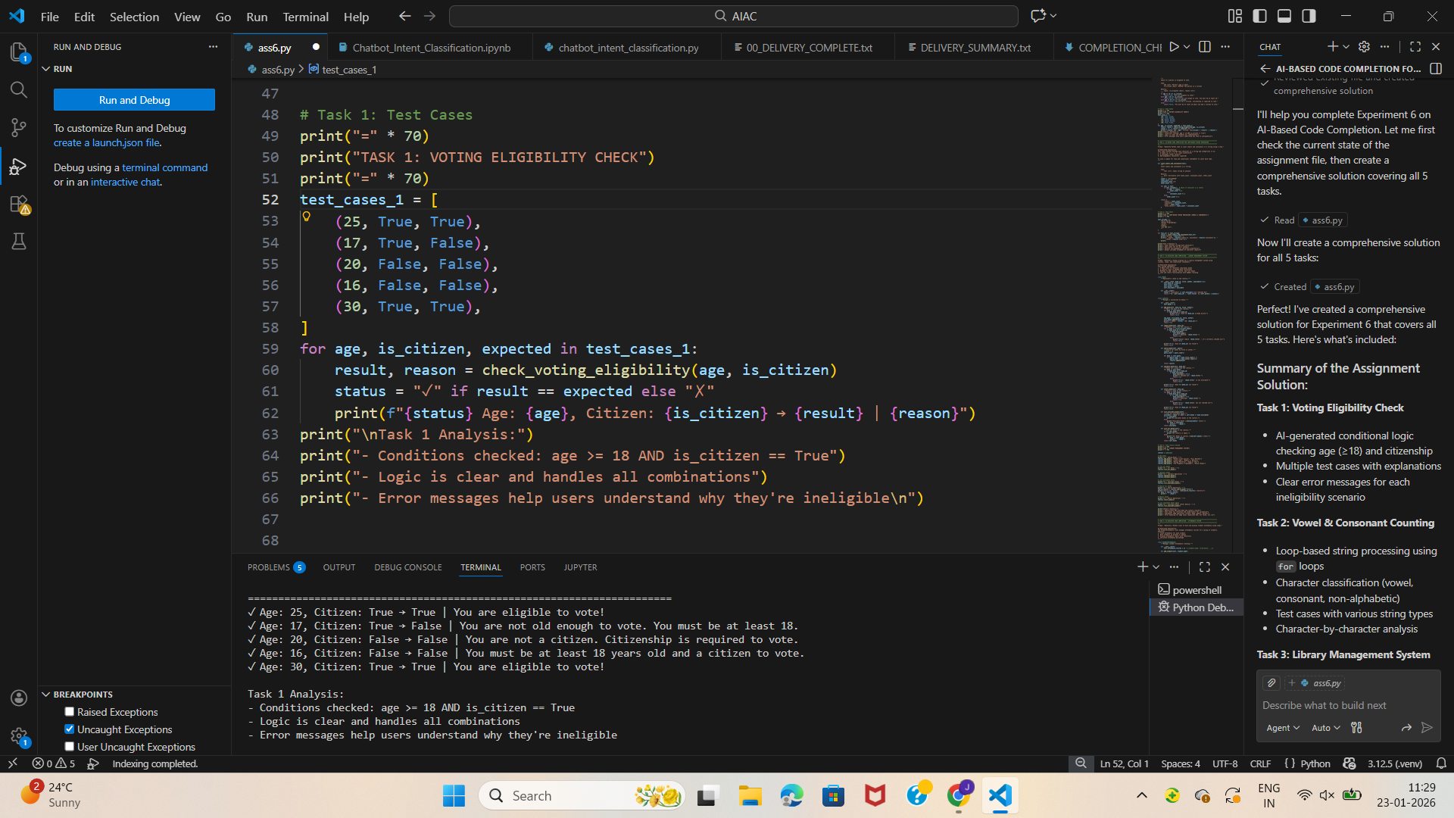

Task Description #2(AI-Based Code Completion for Loop-Based

String Processing)

Task: Use an AI tool to process strings using loops.

Prompt:

“Generate Python code to count vowels and consonants in a string

using a loop.”

Expected Output:

• AI-generated string processing logic.

• Correct counts.

• Output verification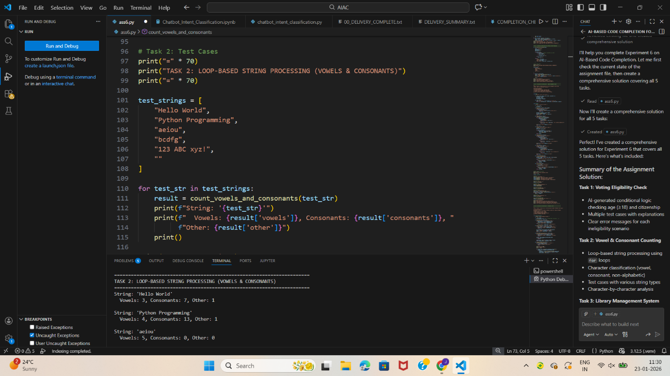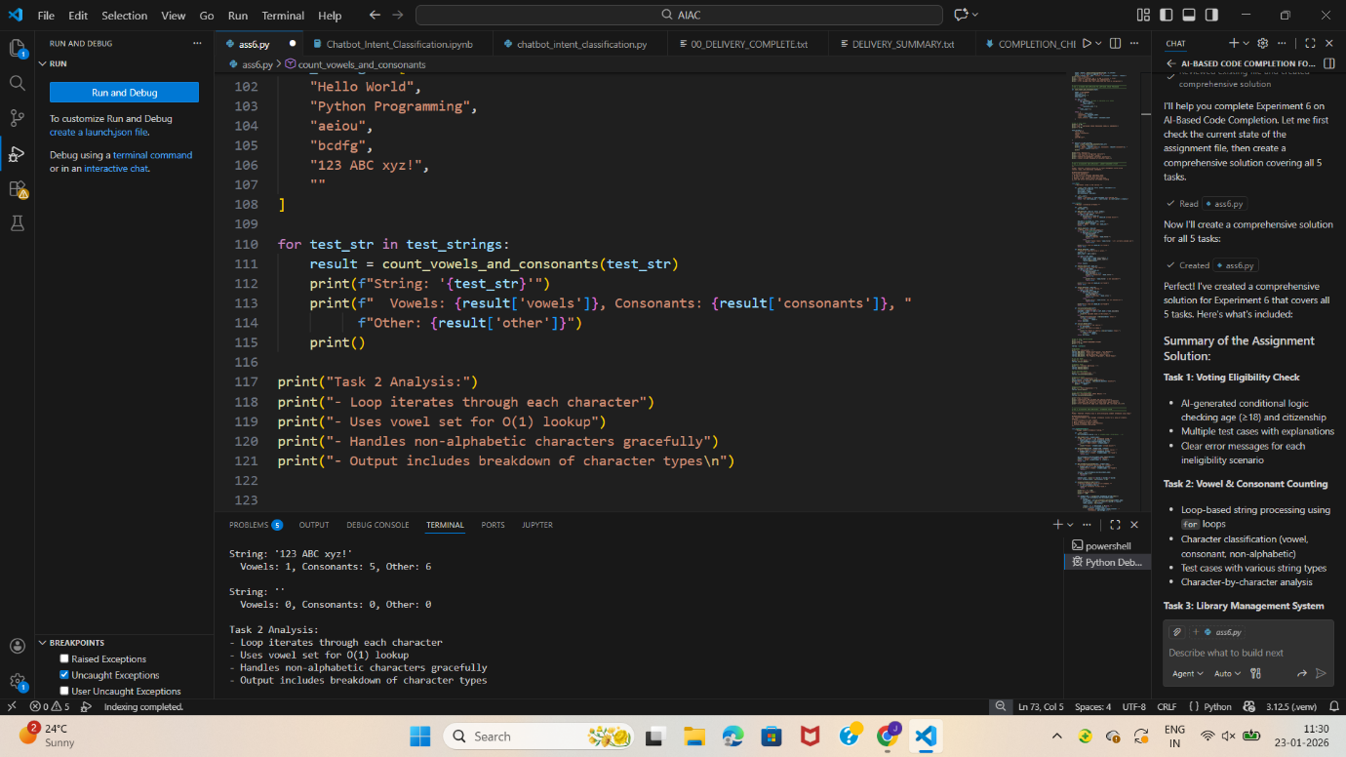

Task Description #3 (AI-Assisted Code Completion Reflection

Task)

Task: Use an AI tool to generate a complete program using classes,

loops, and conditionals.

Prompt:

“Generate a Python program for a library management system

using classes, loops, and conditional statements.”

Expected Output:

• Complete AI-generated program.

• Review of AI suggestions quality.

• Short reflection on AI-assisted coding experience.

Task Description #4 (AI-Assisted Code Completion for Class-

Based Attendance System)

Task: Use an AI tool to generate an attendance management class.

Prompt: “Generate a Python class to mark and display student

attendance using loops.”

Expected Output:

• AI-generated attendance logic.

• Correct display of attendance.

• Test cases.

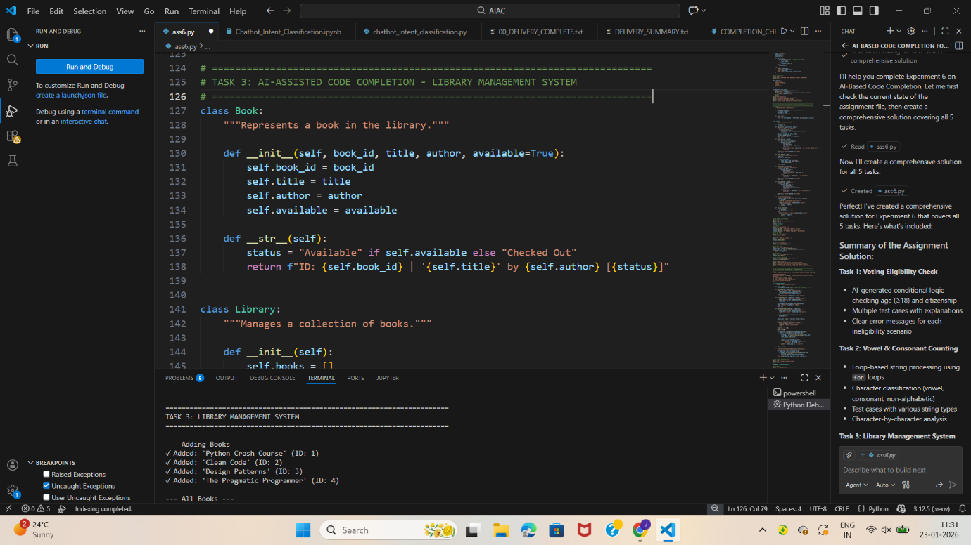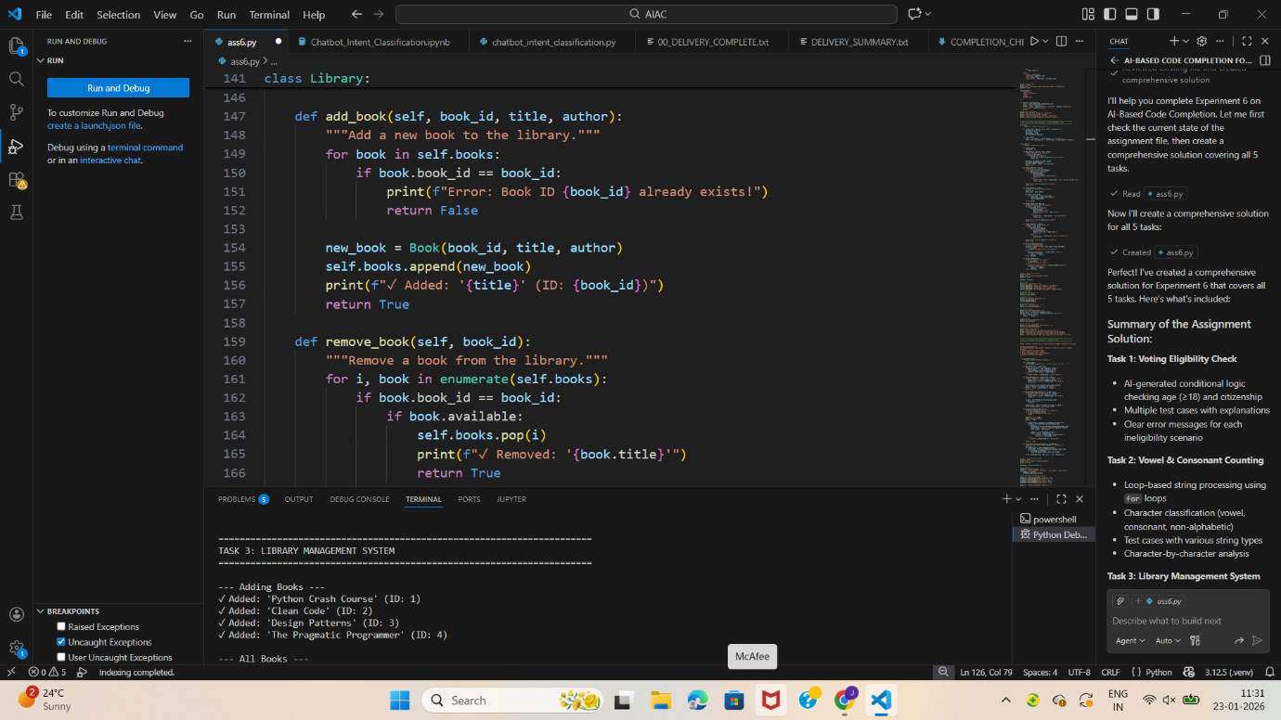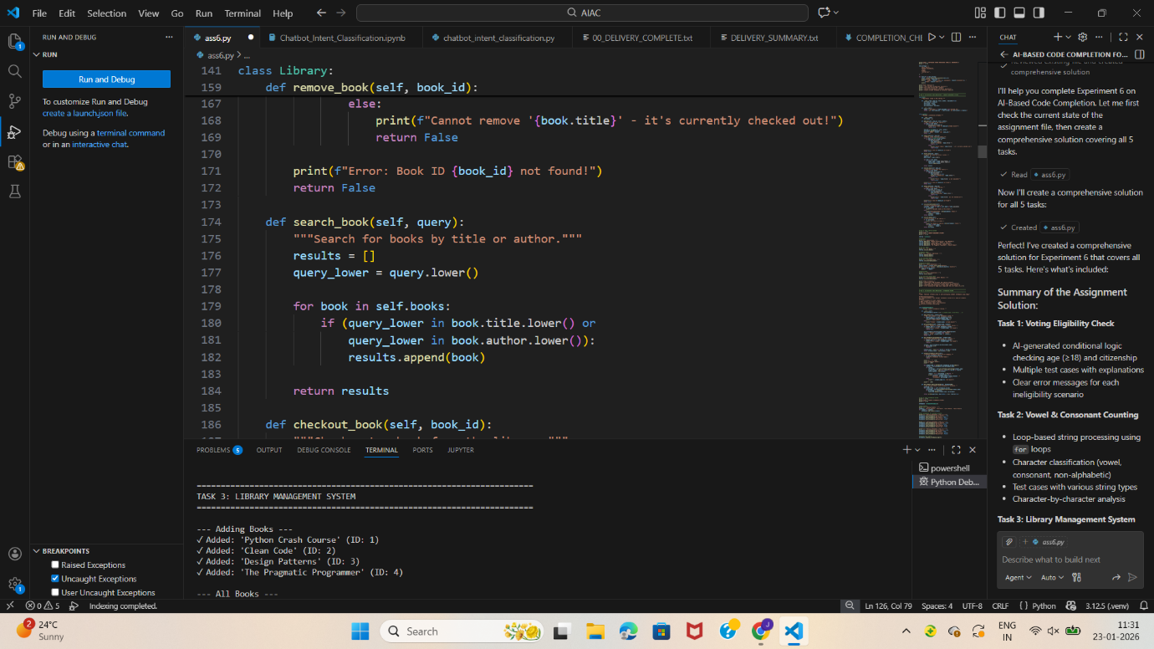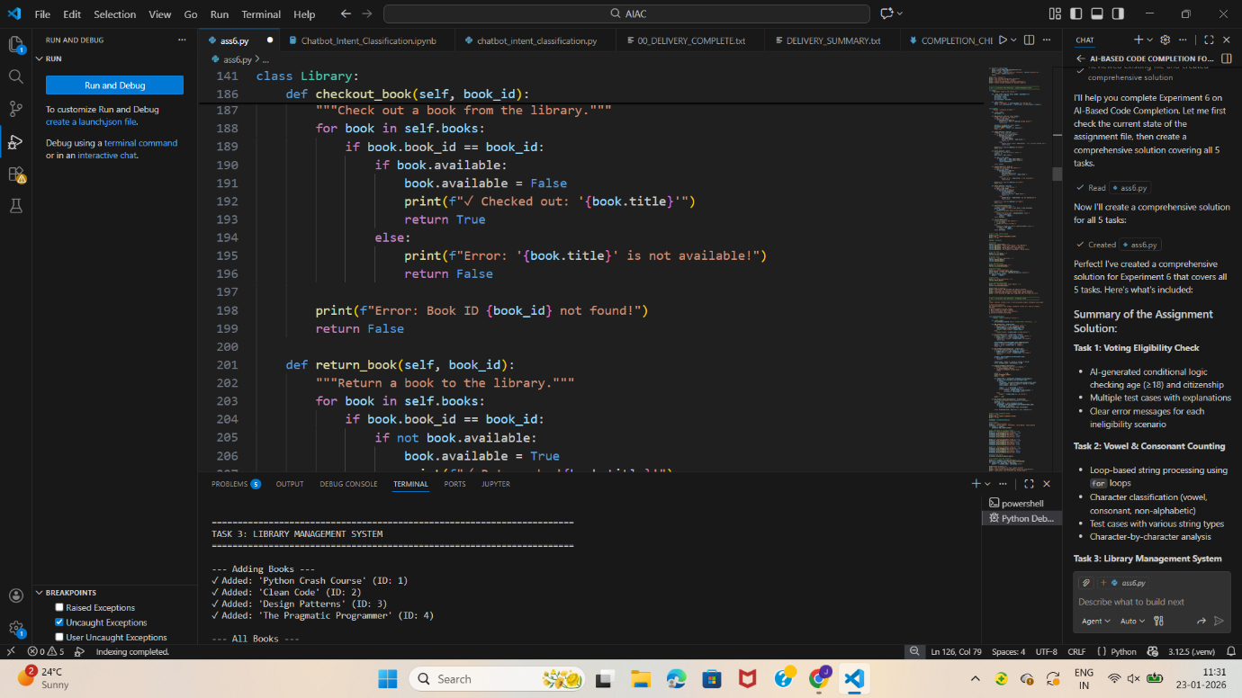

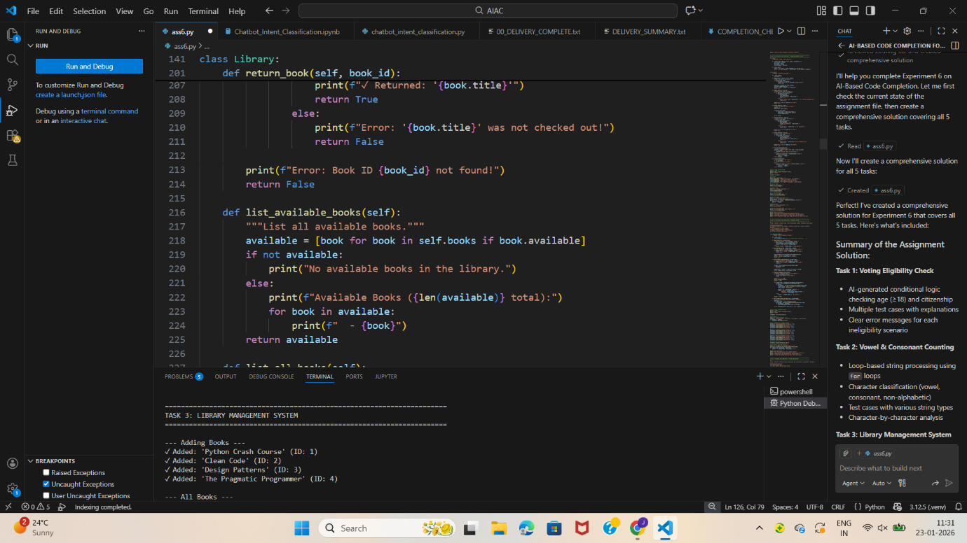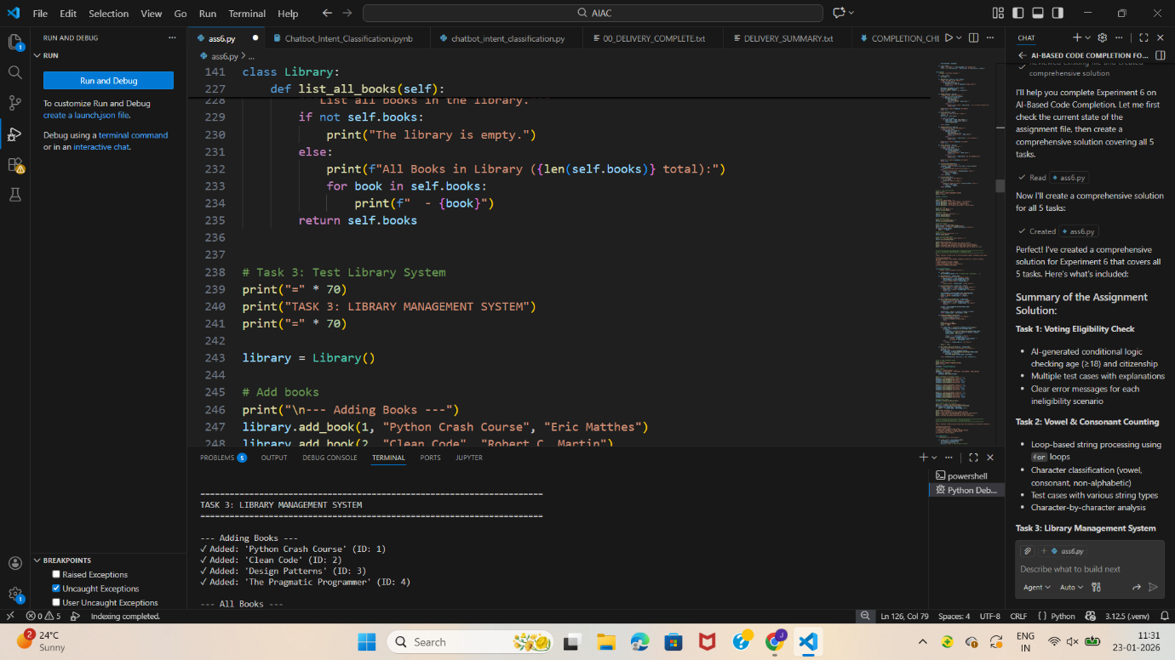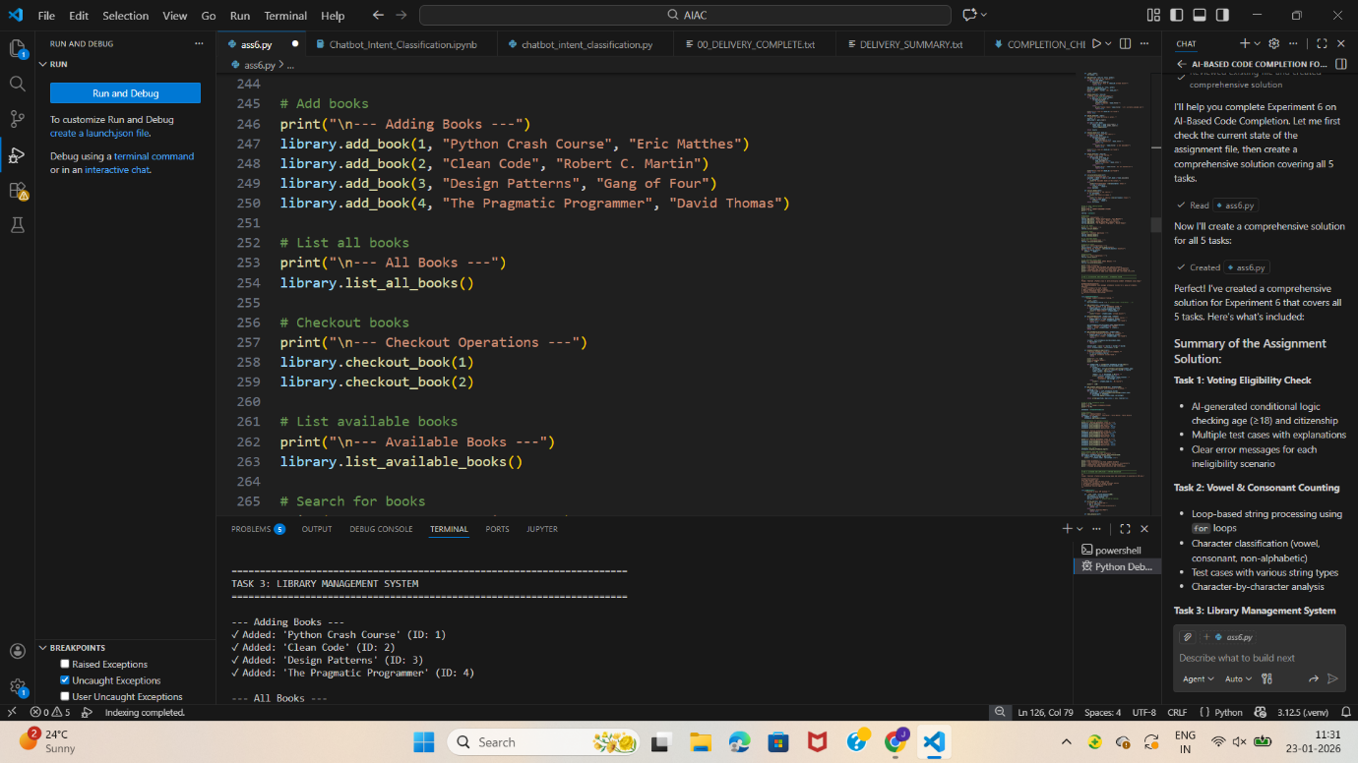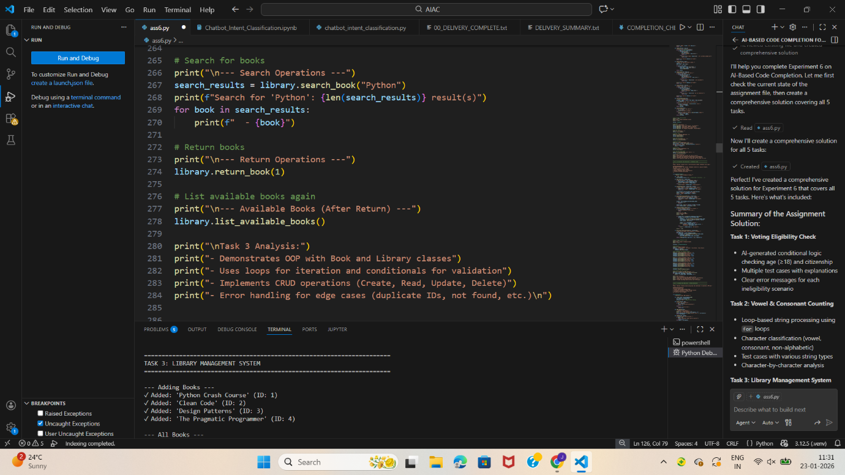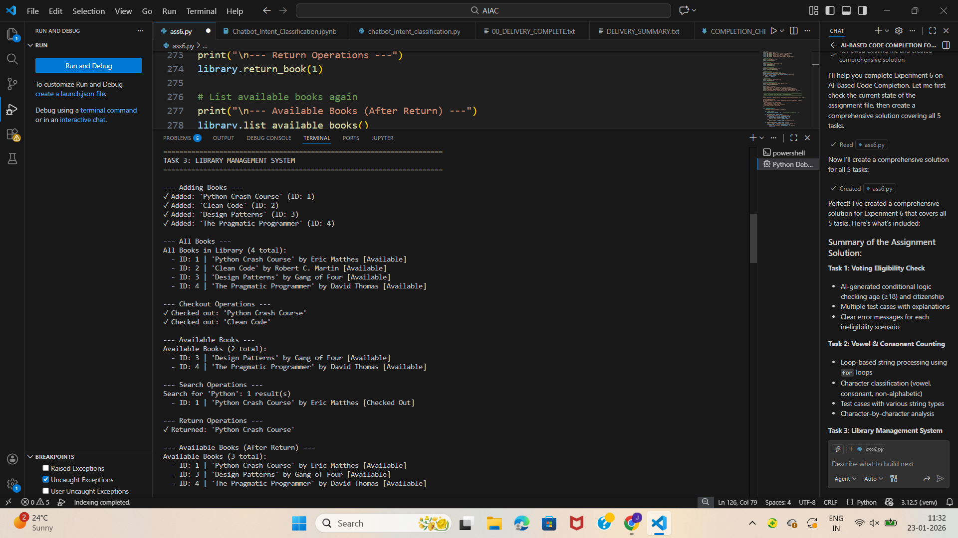

Task Description #4 (AI-Assisted Code Completion for Class-

Based Attendance System)

Task: Use an AI tool to generate an attendance management class.

Prompt: “Generate a Python class to mark and display student

attendance using loops.”

Expected Output:

• AI-generated attendance logic.

• Correct display of attendance.

• Test cases.

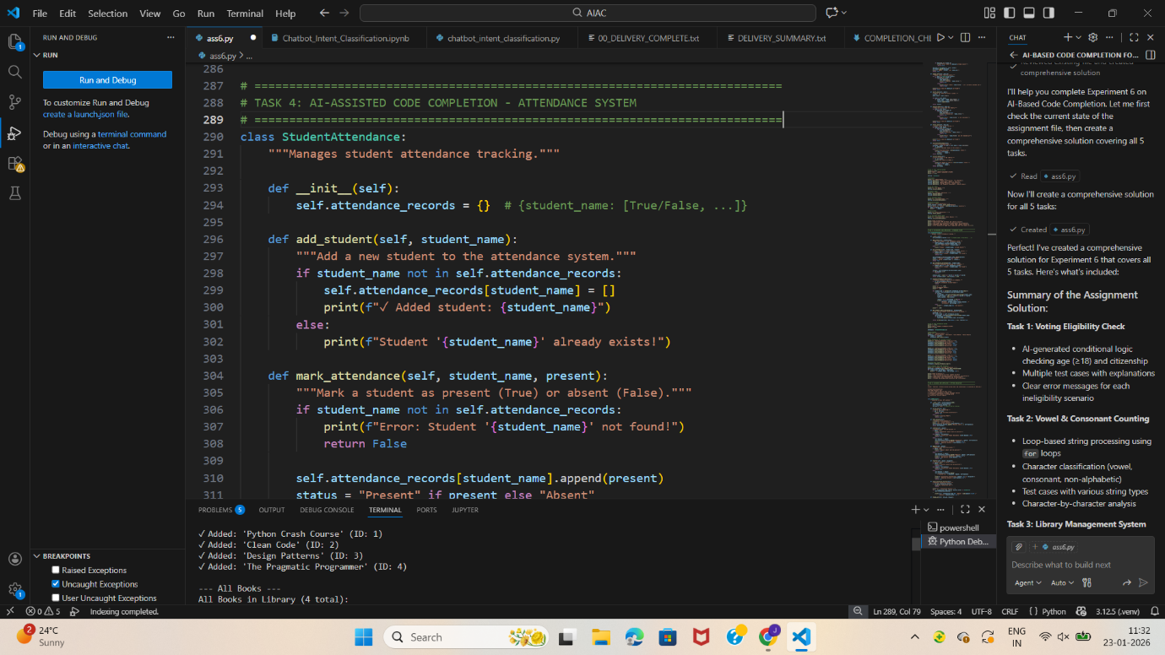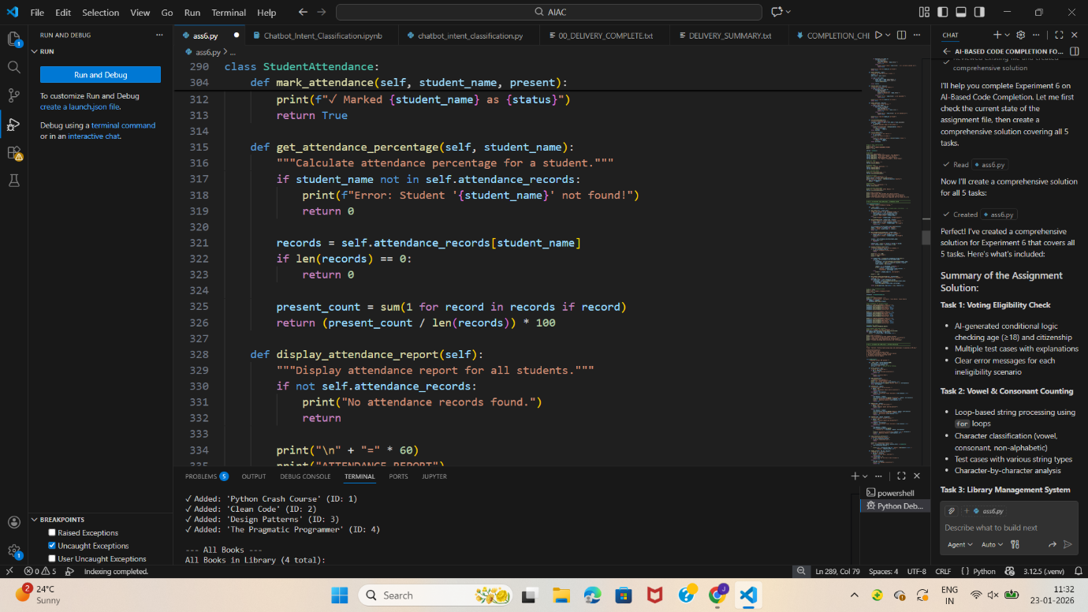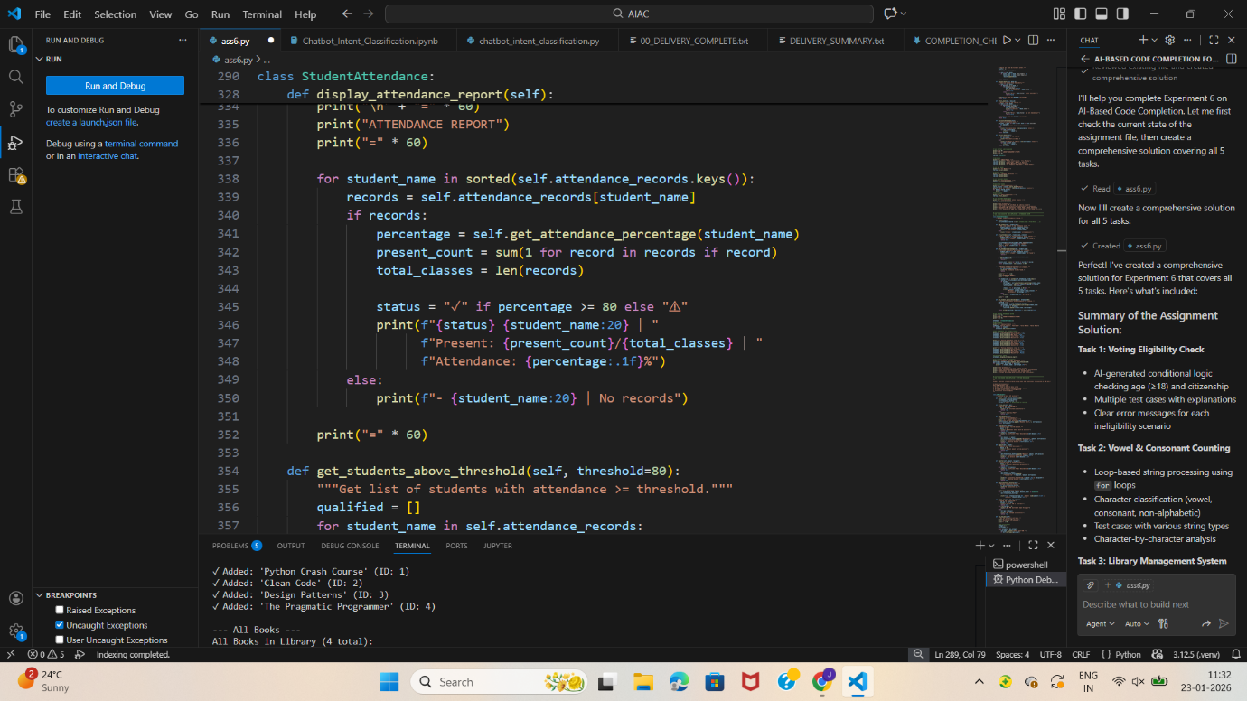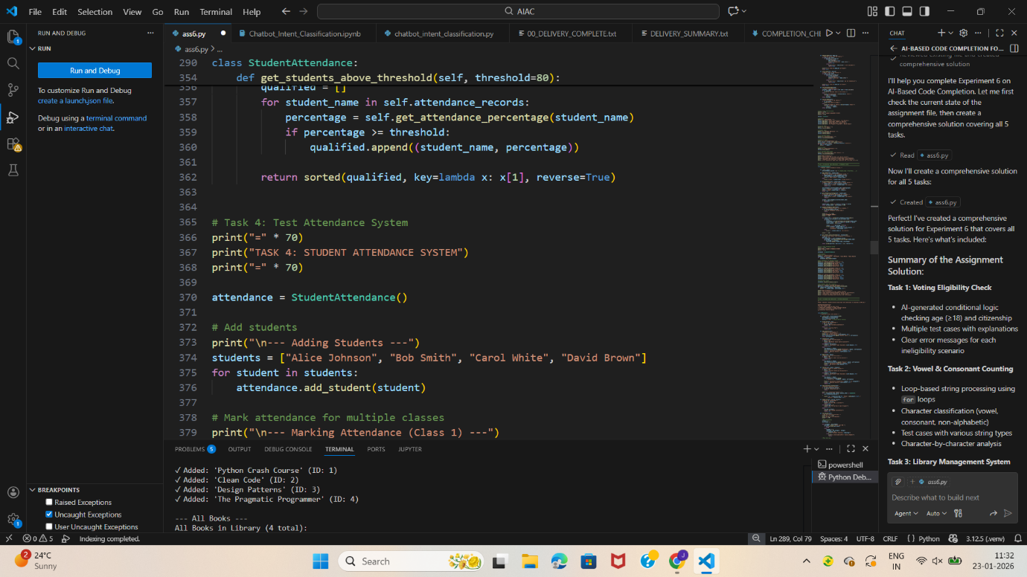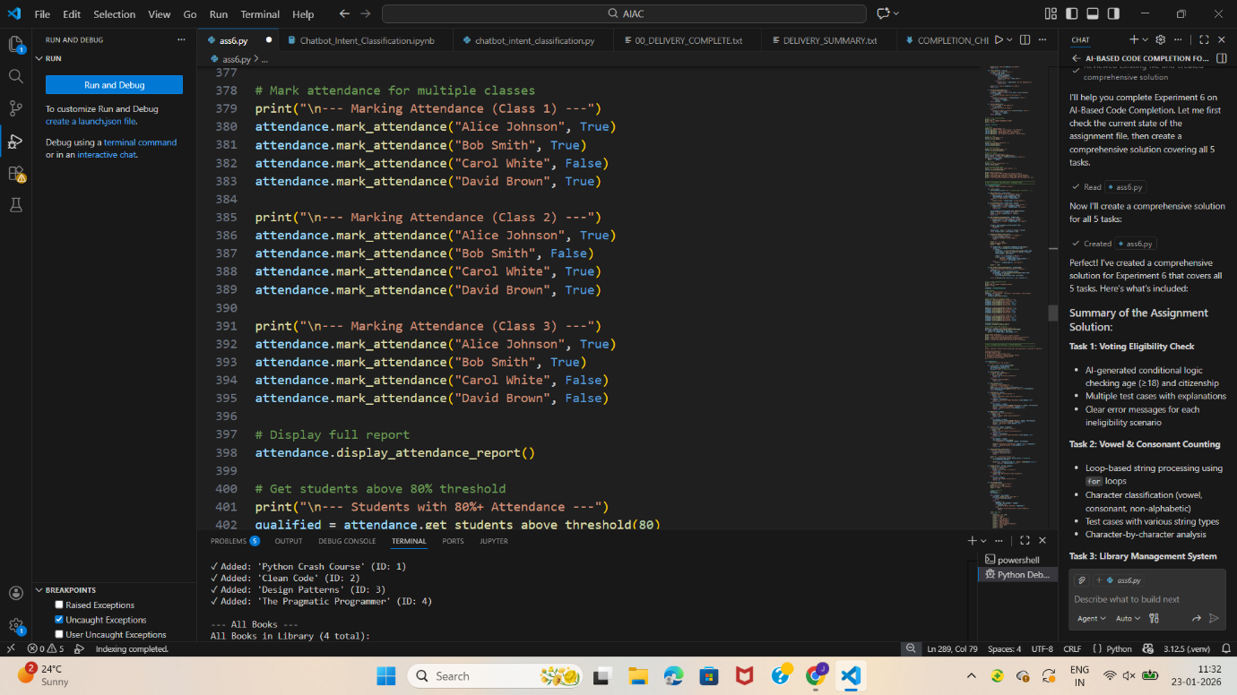

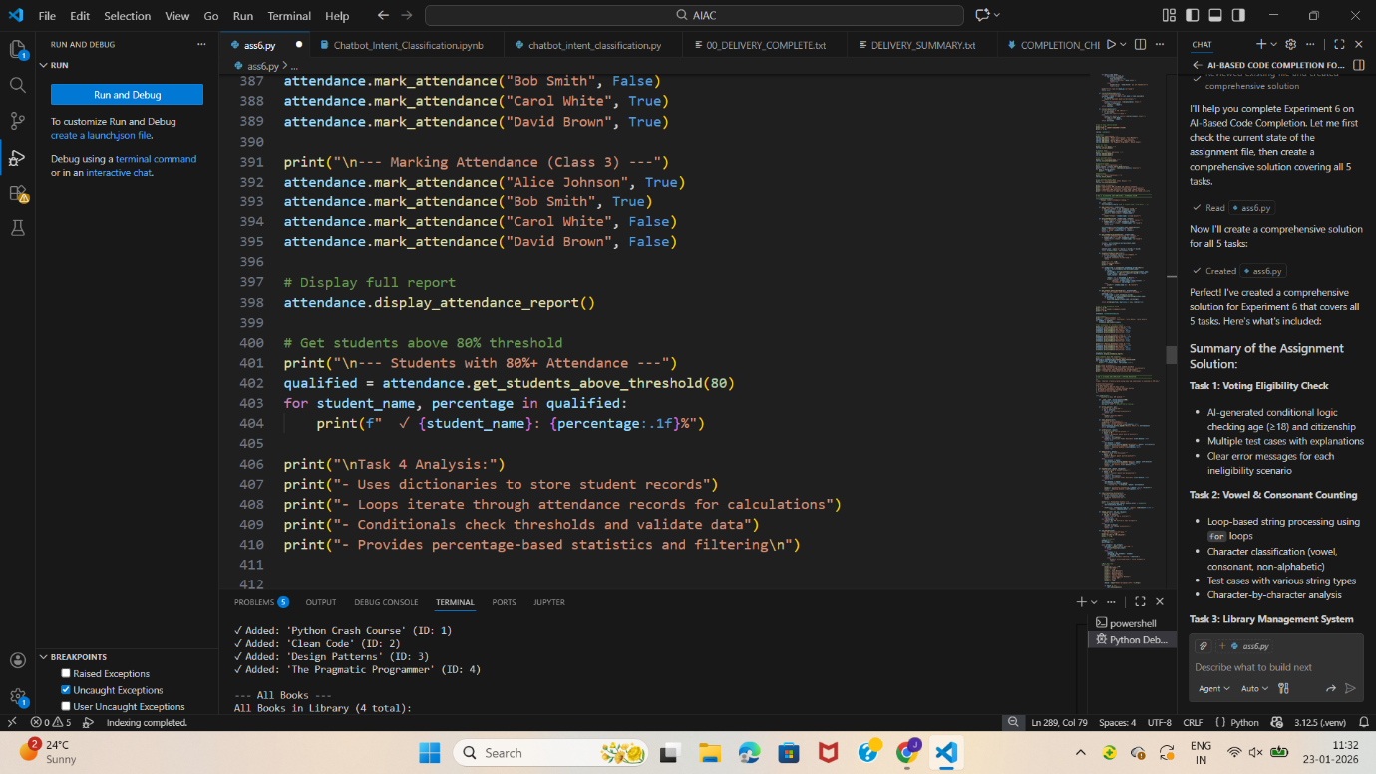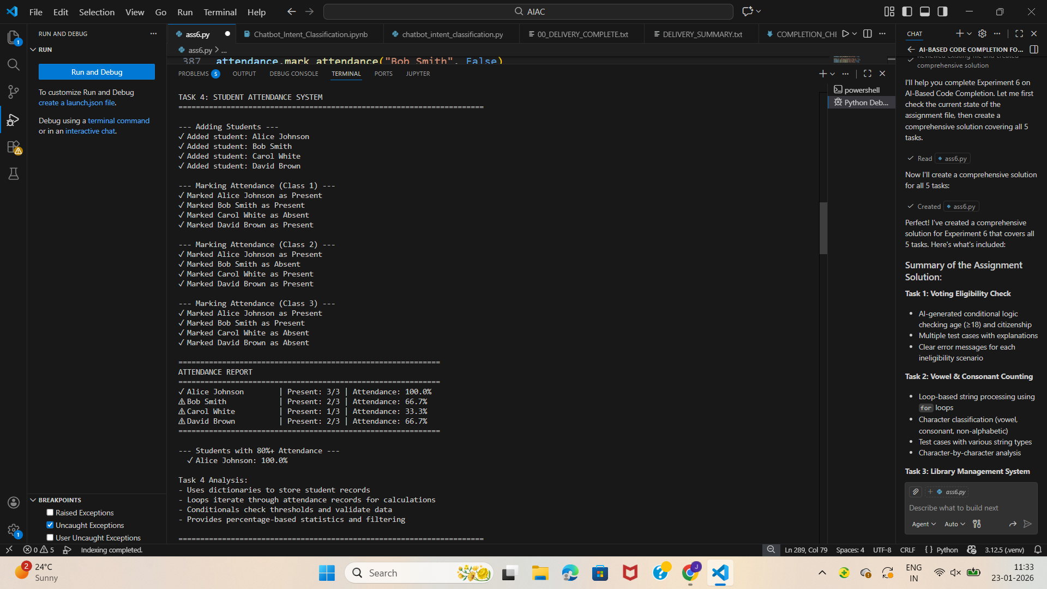

Task Description #5 (AI-Based Code Completion for Conditional

Menu Navigation)

Task: Use an AI tool to complete a navigation menu.

Prompt: “Generate a Python program using loops and conditionals

to simulate an ATM menu.”

Expected Output:

• AI-generated menu logic.

• Correct option handling.

• Output verification.

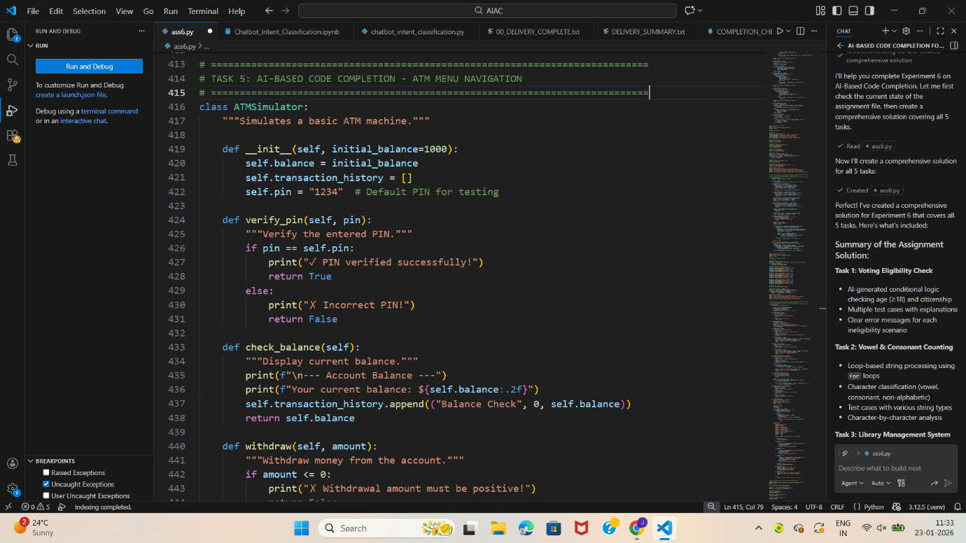

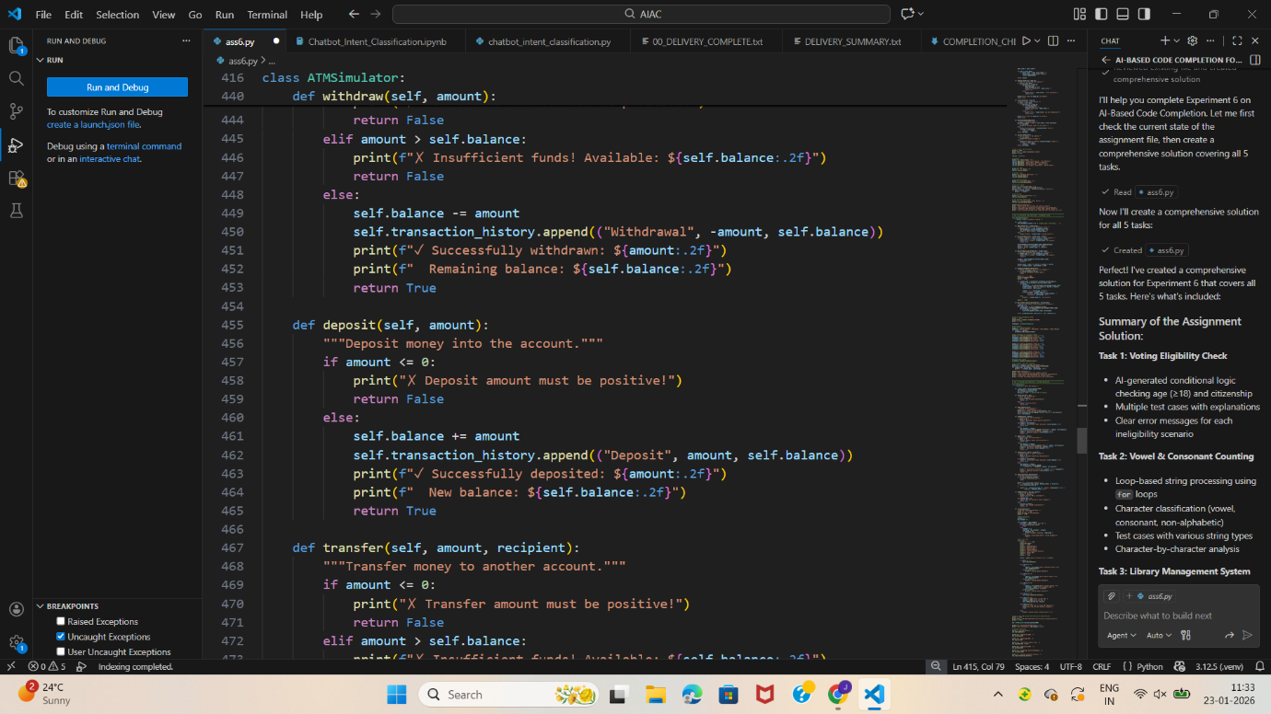

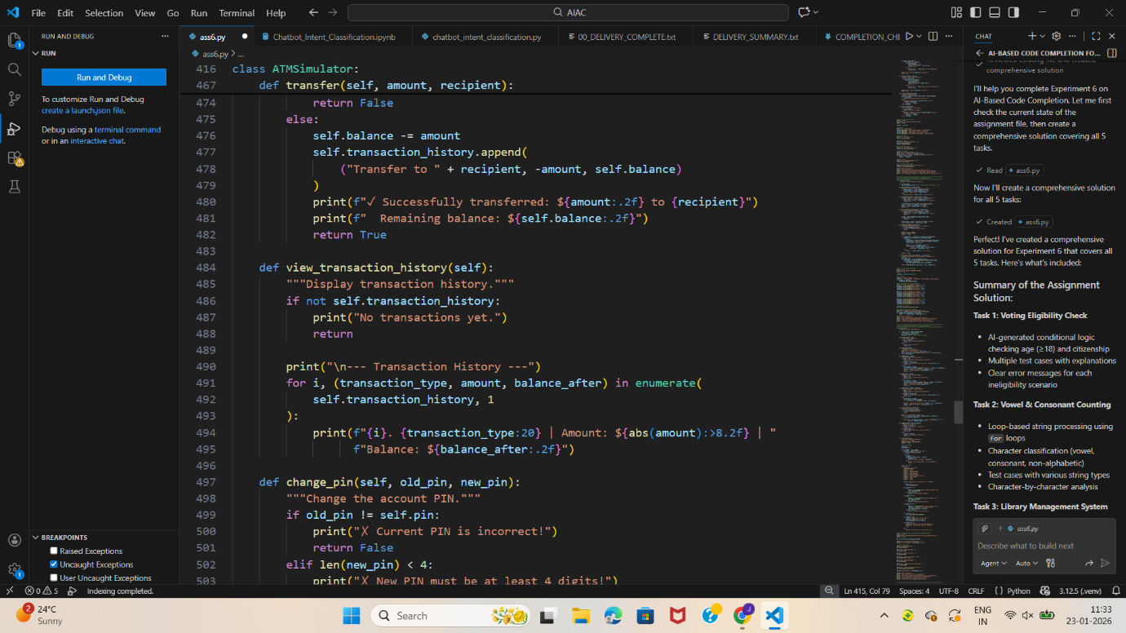

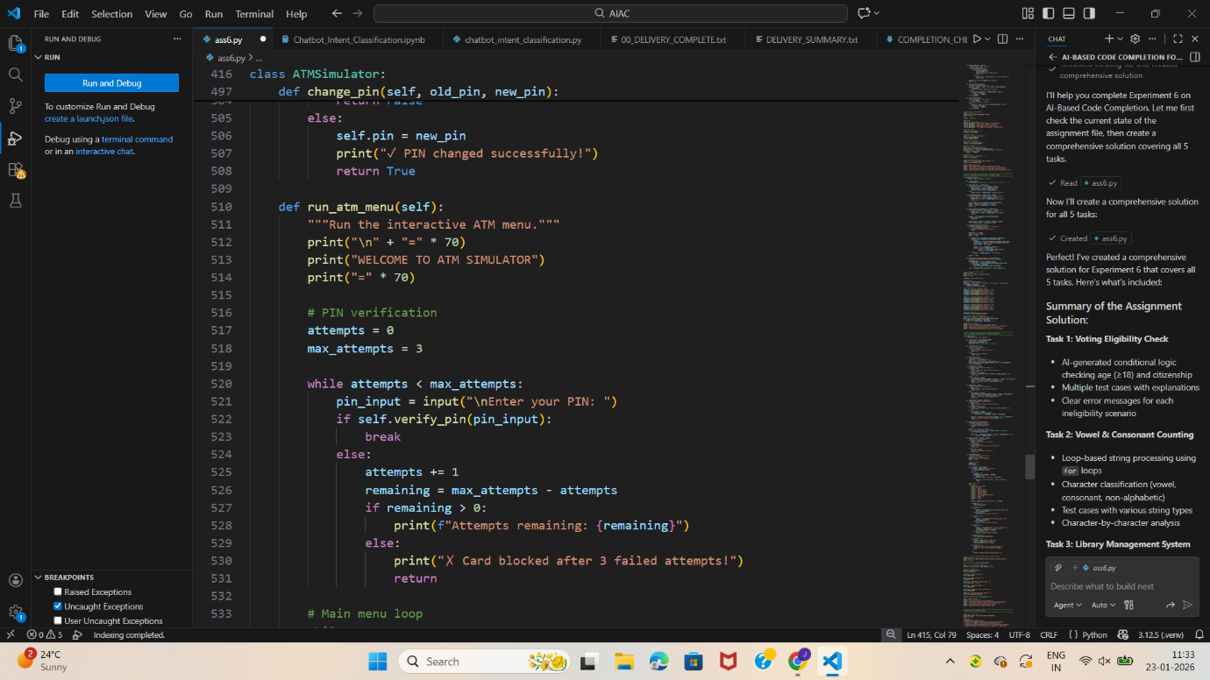

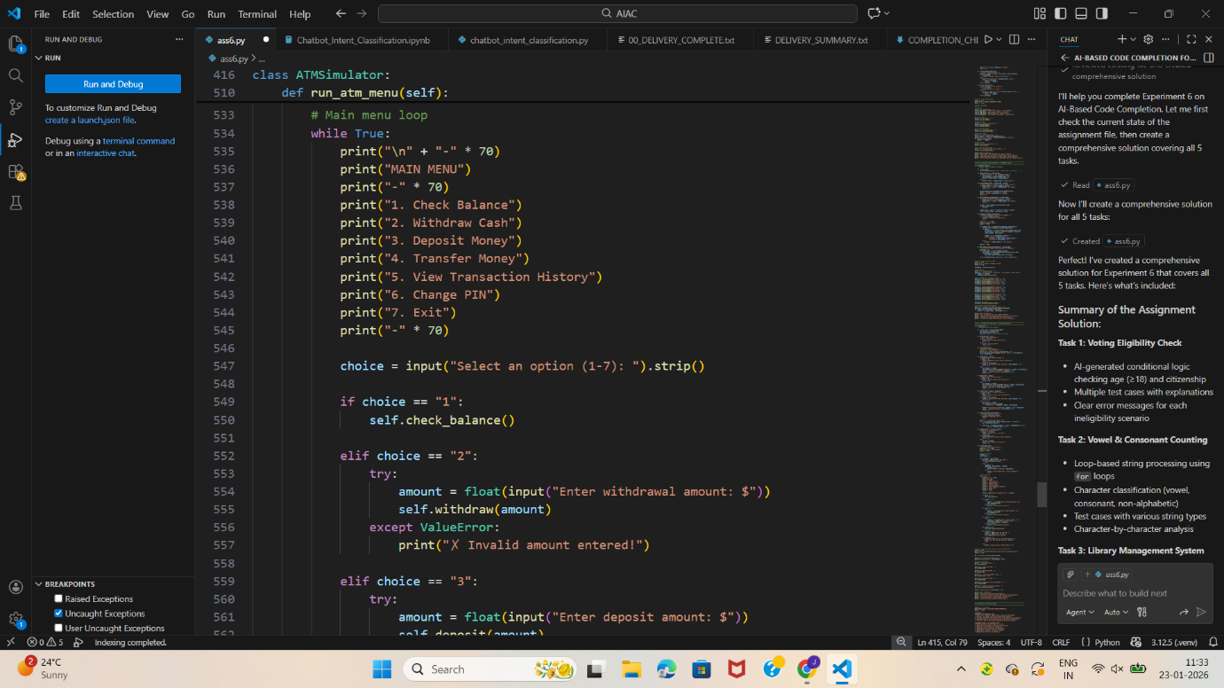

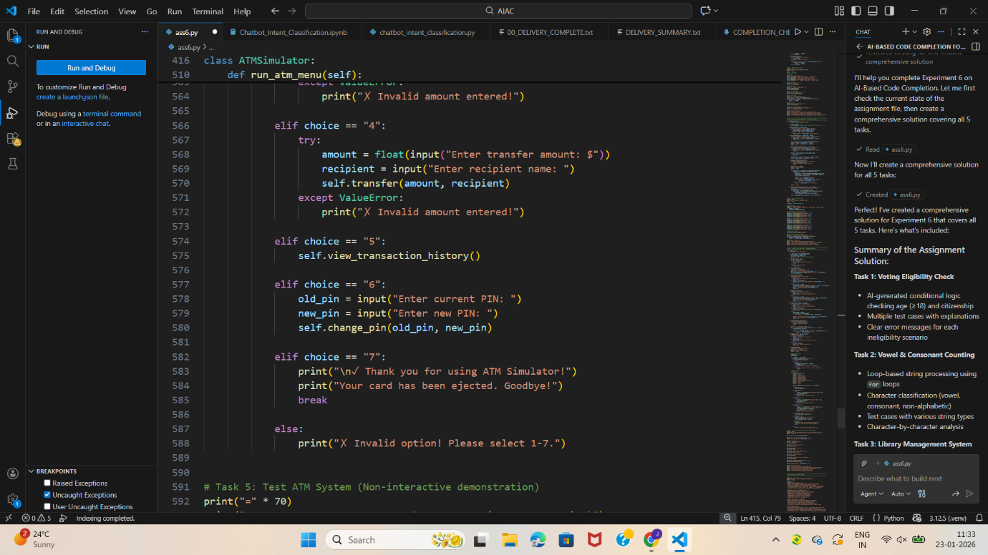

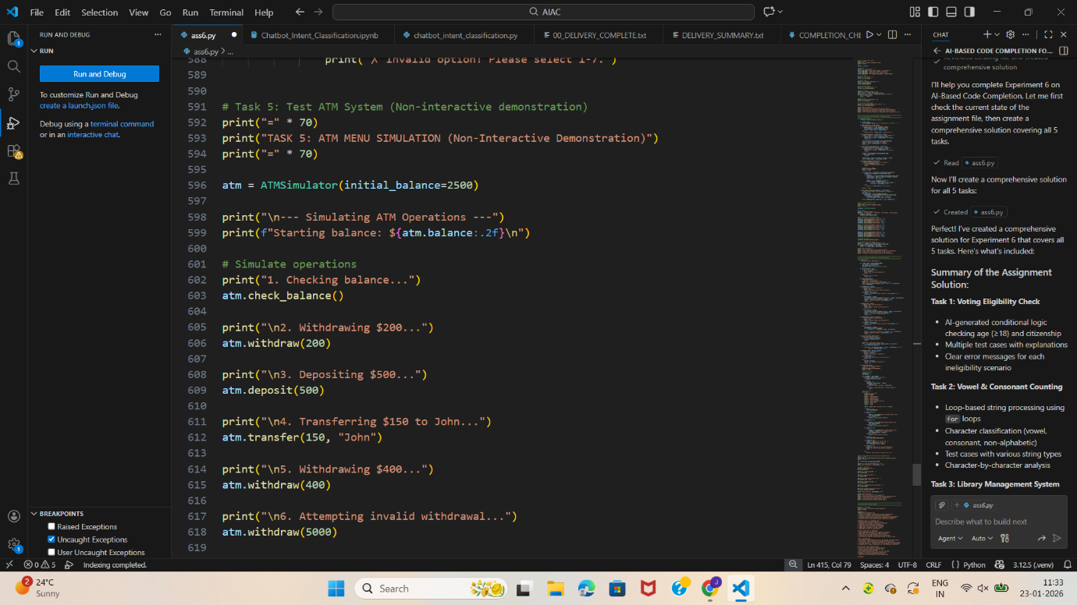

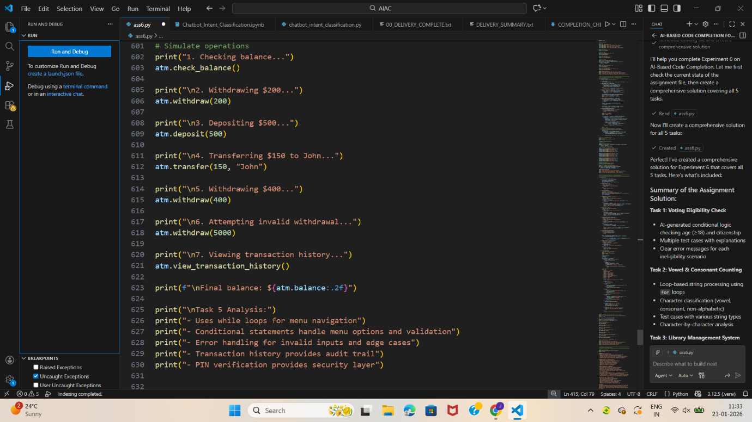

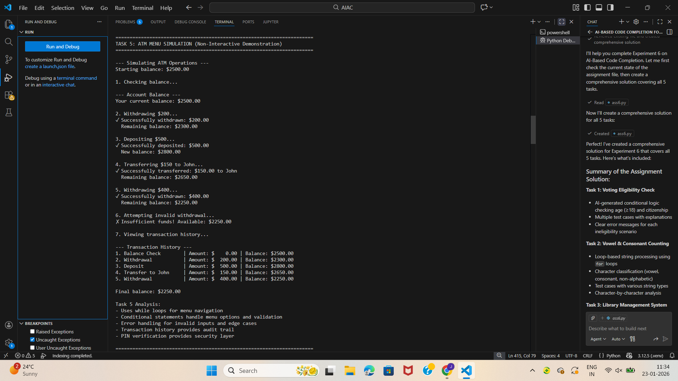

**Summary of the Assignment Solution:**

**Task 1: Voting Eligibility Check**

* AI-generated conditional logic checking age (≥18) and citizenship
* Multiple test cases with explanations
* Clear error messages for each ineligibility scenario

**Task 2: Vowel & Consonant Counting**

* Loop-based string processing using for loops
* Character classification (vowel, consonant, non-alphabetic)
* Test cases with various string types
* Character-by-character analysis

**Task 3: Library Management System**

* Complete OOP implementation with Book and Library classes
* Features: add, remove, search, checkout, return books
* Demonstrates CRUD operations and error handling
* Real-world example of classes + loops + conditionals

**Task 4: Student Attendance System**

* StudentAttendance class for tracking attendance
* Methods to add students, mark attendance, calculate percentages
* Attendance report with statistics
* Filtering students by attendance threshold (80%+)

**Task 5: ATM Menu Simulation**

* ATMSimulator class with full banking operations
* Operations: balance check, withdraw, deposit, transfer
* PIN verification and transaction history
* Non-interactive demonstration with realistic scenarios

**Plus:**

* Comprehensive documentation and explanations for each task
* Test cases demonstrating correctness
* Analysis of each solution's key features
* **Reflection on AI-Assisted Coding** covering strengths, improvements, ethical considerations, and best practices

The file is ready to run and demonstrates all the learning objectives (LO1-LO5) with proper code interpretation, error identification, optimization, and ethical considerations.